Word Press websites Scan

- Objective:
Use WP Scan to identify and prioritize security issues on a WordPress site (outdated core/plugins/themes, exposed users, risky settings), then remediate and verify fixes with a re-scan.

- Overview:
WP Scan is a command-line scanner for WordPress that checks the core, plugins, themes, and users against a vulnerability database. It helps quickly spot known weaknesses and misconfigurations so you can patch and harden the site.

- Step-By-Step:
Step 1: Install WP Scan, sudo apt install wpscan
Step 2: Scan Word Press Website wpscan --url website link

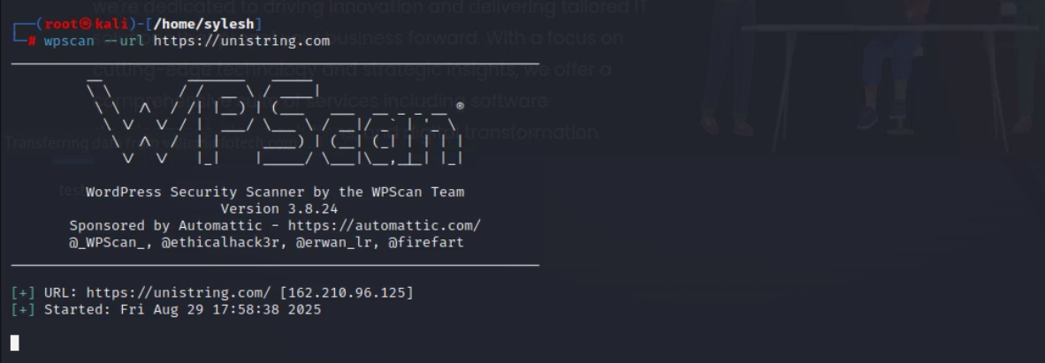
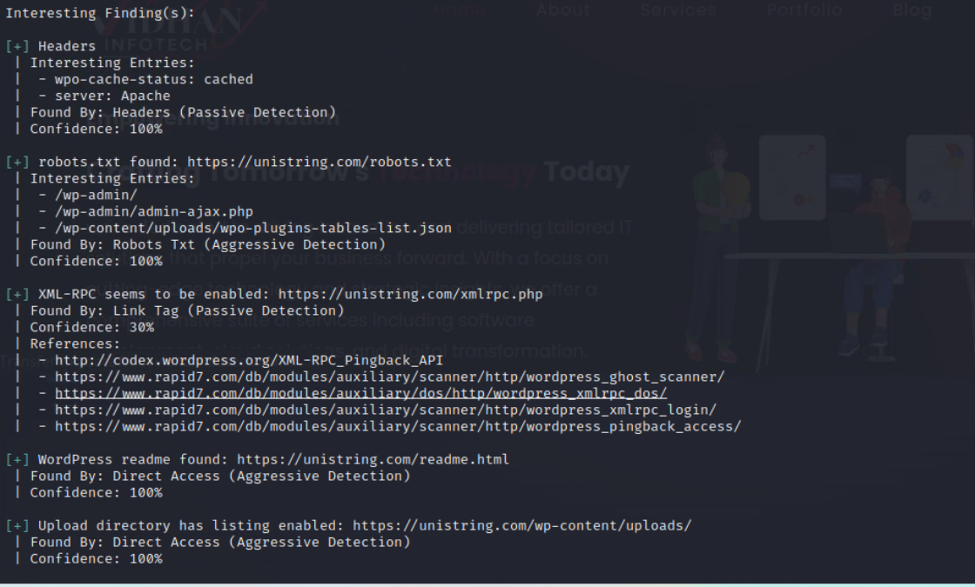
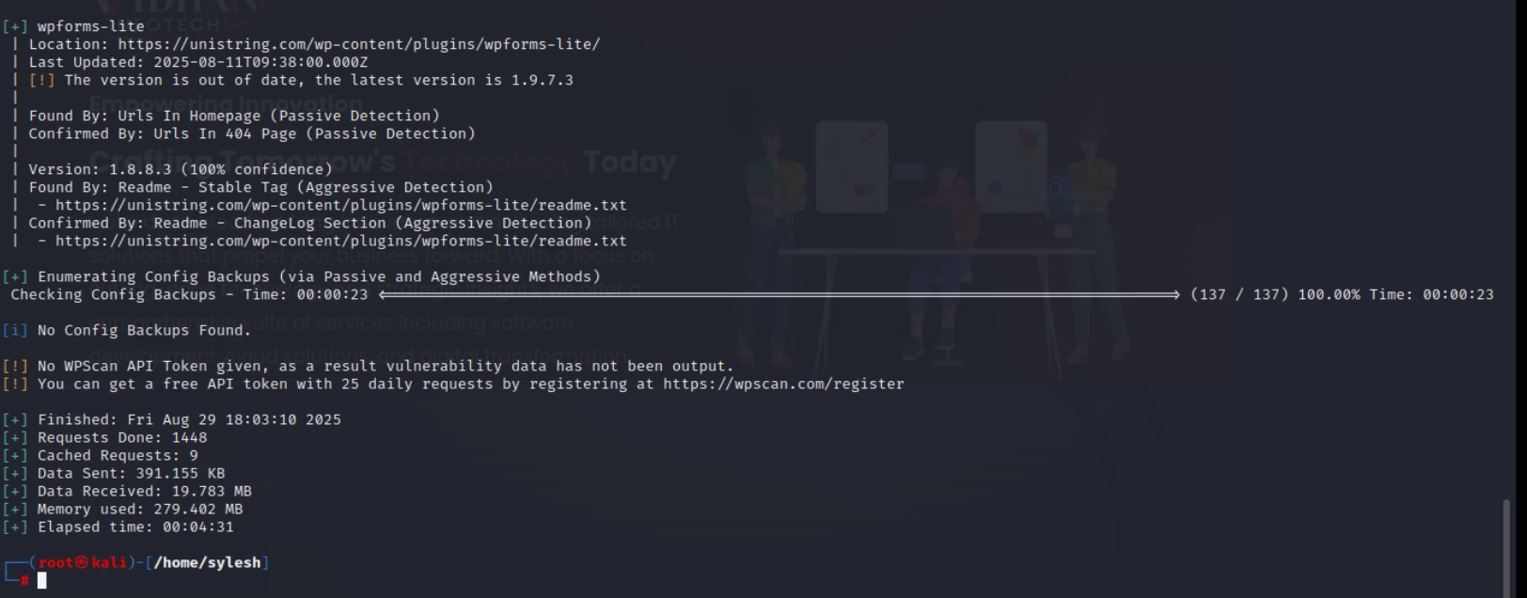

Step 3: Enumerate check wpscan –url website link --enumerate vp ,p for plugins

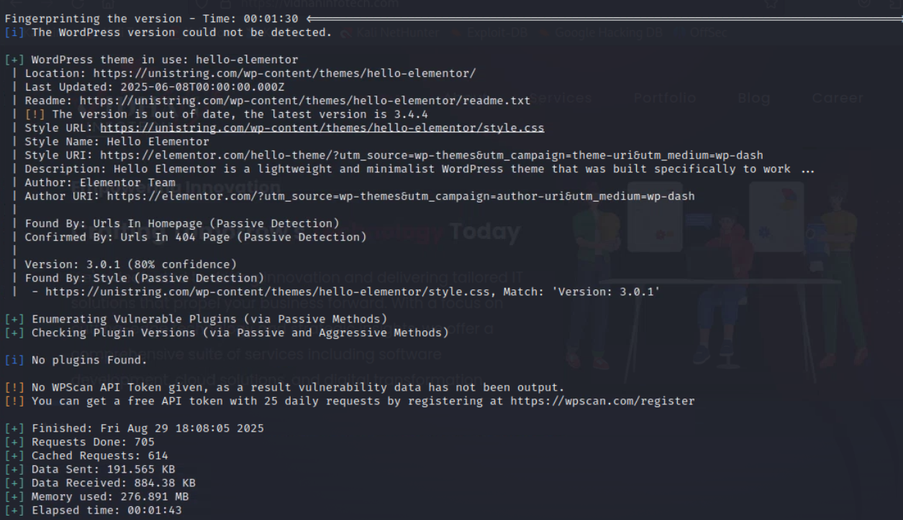

Step 4: Enumerate check wpscan –url website link --enumerate vt ,t for theme
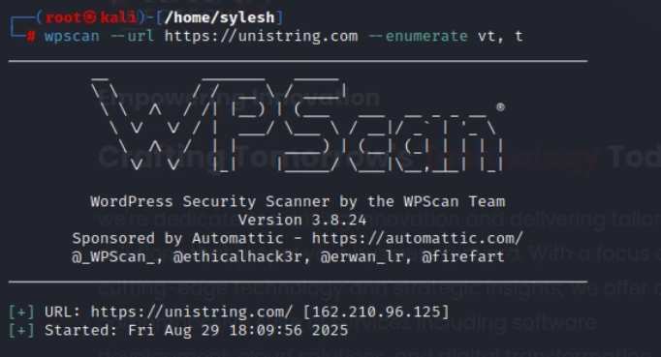


Step 5: Enumerate check wpscan –url website link --enumerate u for users
